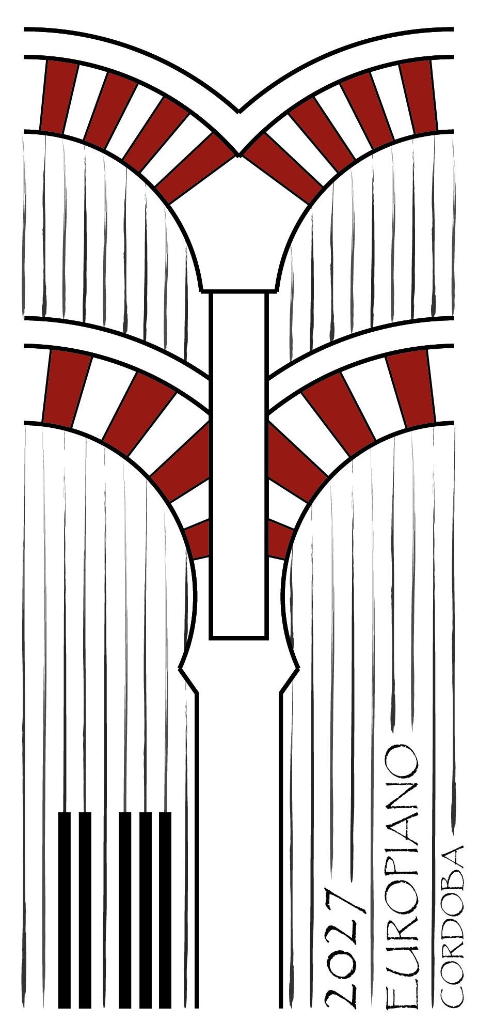

EUROPIANO CONGRESS CÓRDOBA 2027
16 - 18 April 2027 · Córdoba, Spain

Dossier of activities for accompanying persons during the congress

EUROPIANO CONGRESS CÓRDOBA 2027 Activities for accompanying persons

Thursday 15 April - evening
Welcome cocktail — 7:00 PM. Official congress reception. Welcome cocktail for congress participants and their guests, and distribution of accreditation badges.

Friday 16 April — morning
Tourist Bus (Ticket validity: 48 hours) — 9:30 AM–6:30 PM.
Departure red line (Stop 16, Römerbrücke) / blue line (Stop 1, Alcázar). Two routes with open double-decker bus (Intimate Córdoba and Panoramic Córdoba) with 48-hour ticket, guided walking tour through the Jewish Quarter (6:00 PM, 1 hour, in Spanish and English) with access to the Courtyards of San Basilio and the Viana Palace.

Patios de San Basilio — Courtyards. Opening hours: Wednesday to Monday, 10:30 AM. San Basilio, 40, red line. Popular courtyards of the neighborhood of the same name, representative of the Cordoban tradition of flowers and ceramics, particularly impressive in spring.
Palacio de Viana — Courtyards included in the bus ticket. Opening hours: Monday 10 AM – 3 PM; Tuesday to Saturday 10 AM – 7 PM; Sunday 10 AM – 3 PM. Stop 5, blue line. Fifteenth-century aristocratic palace with twelve landscaped courtyards. Only the courtyards are accessible; the palace interior is not included.
Friday 16 April — afternoon
Free tour on the tourist bus at various stops on the red or blue lines until 6:30 PM.
Friday 16 April — evening
Dinner — 9:00 PM. Venue to be determined.

Saturday, April 17 — morning
Medina Azahara — Guided tour of the archaeological site
At 9:00 AM we travel by bus to the archaeological quarter.
At 10:00 AM at the site, duration approximately 3 hours.
The caliphal palace city (10th century), declared a UNESCO World Heritage Site in 2018, was built by Abd al-Rahman III 8 km from Córdoba. It impresses with its ataurique decorations and a spectacular Salón Rico with arches of multicolored marble.
Saturday, April 17 — afternoon
Mezquita-Cathedral of Córdoba — 4:00 PM–6:00 PM. A masterpiece of Andalusian architecture (8th–10th centuries), within which a cathedral in Renaissance style was built after the conquest. UNESCO World Heritage Site.
Concert at the Professional Music Conservatory Auditorium – 7:00 PM. Concert in the facilities of the Professional Music Conservatory in the recently renovated concert hall with a capacity of 300 seats.
Saturday, April 17 — evening
Gala Dinner at Bodegas Campos — 9:00 PM. Dinner at one of the city of Córdoba's most famous centuries-old wineries, where you can enjoy the culinary delicacies of the province.

